Volunteer Application | 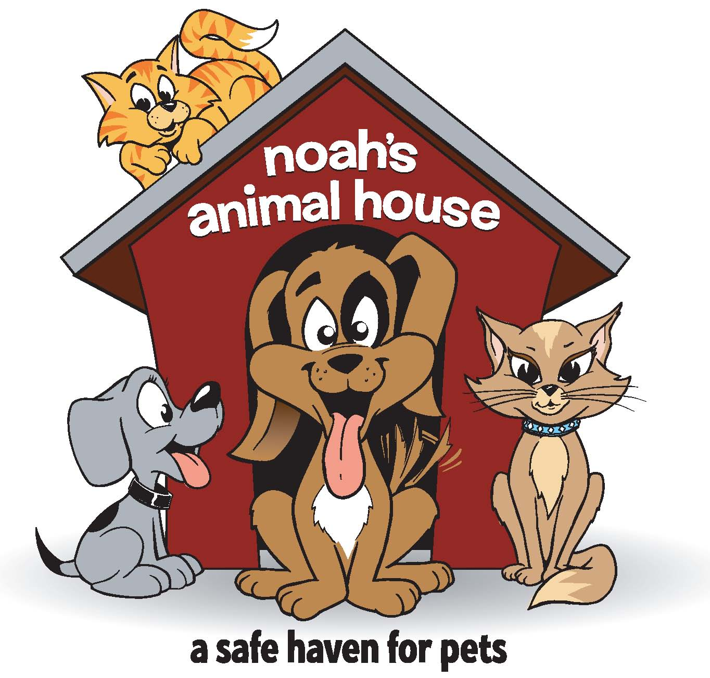

Contact Information
Name
Street Address
City ST ZIP Code
Home Phone
Work Phone
E-Mail Address
Employer/School Name
Site Choice (Please circle) | Las Vegas Reno

Availability

During which hours/times are you available for volunteer assignments?
Weekday mornings | Weekend mornings
Weekday afternoons | Weekend afternoons
Weekday evenings | Weekend evenings
___ Weekly schedule | ___ More than once per week
___ Monthly schedule | ___ Occasional

Interests

Tell us in which areas you are interested in volunteering. Please let us know of at least one area of interest.
Administrative/Computer
Special Events at Noah’s
Sorting and storing donations for the pets
Fundraising
Direct Pet Care
Awareness Events in the community
___ Other (example please) ____________________________________________________________

Special Skills or Qualifications

Summarize special skills and qualifications you have acquired from employment, previous volunteer work, or through other activities, including hobbies or sports.

Previous Volunteer Experience

Summarize your previous volunteer experience.

Person to Notify in Case of Emergency
Name
Street Address
City, ST, & ZIP Code
Home Phone
Work Phone
E-Mail Address

Agreement and Signature

By submitting this application, I affirm that the facts set forth in it are true and complete. I understand that if I am accepted as a volunteer, any false statements, omissions, or other misrepresentations made by me on this application may result in my immediate dismissal.
Name (printed)
Signature
Date
Parent Name (if under 18 years old)
Parent Signature
Date

Our Policy

It is the policy of this organization to provide equal opportunities without regard to race, color, religion, national origin, gender, sexual preference, age, or disability.
Community Service Volunteers for Court are not eligible.
Community Service Volunteers for school and service clubs are eligible. Please notify us of need for documented proof of service.

Thank you for completing this application form and for your interest in volunteering with us.
Please submit this form to info@noahsnv.org.

